**Willow Tree Primary School 23.10.20**

**Nursery Weekly Newsletter Newsletter**

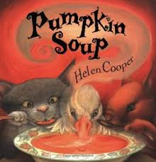

**This week**

We have had such a grand finale

to this busy half term!

We have been chopping, making and

tasting pumpkin soup, linked to our story of the week ‘Pumpkin Soup’ by Helen Cooper. The children had such fun smelling, touching and describing the texture of the stringy pumpkin flash. They used the remains in the mud kitchen, pretending to make their own soup! Later in the week, we carved the pumpkins and used apple halves to print pumpkin shapes, mixing our own orange paint using red and yellow. We then counted how many we had printed and found the number to copy on our pictures.

Outside, many of our children have been learning how to correctly write their first letter in their names, using the chalks on our flower boards. Well done!

Friday was fantastic! We ended our term with a ‘spooky day’, dressing up and having lots of spooky fun!

Enjoy your half term break and don’t forget to share any ‘wow’ moments with us on Tapestry!

**NEXT WEEK**

**Our learning challenge will be:**

**How can we stay safe on Bonfire Night?**

Such an exciting week as we return after half term. Linked to our story of the week, we will be exploring fluorescent paints and glitter to make bonfire pictures and making our own 3D rockets. We will be role-playing the story using props and singing 5 little fireworks using numbered rockets. Later in the week, we will be watching a power point on how to stay safe on Bonfire Night.

The story of the week will be:

Whatever Next by Jill Murphy

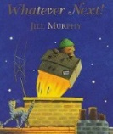

**READING**

Library books will be collected in for the half term. This is a good opportunity to take a look on the online Bug Club using your child’s personal login (sent out previously) Please look at the same story for several visits, as this gives children the chance for repetition and build confidence in story prediction and become familiar with the story language!

**PIGGY MONEY**

Piggy money is not being collected at the moment. We will let you know when this changes.

Thank you ☺



HOME TASK –

**During half term, why not have an Autumn treasure hunt using the tick sheet we sent home. See what amazing Autumn things you can find from the list and don’t forget to share the experience with us on Tapestry! Have fun and stay safe this half term!**

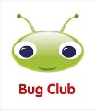

**MESSAGES-**

**\*Please send your child into Nursery with a pair of gloves on Thursday 5th November…we have a very special treat in store!**

**SSSHHH! Don’t tell the children…**

**It’s top secret!**

**SUPERSTAR OF THE WEEK**

**Casey – for showing kindness and helping others in Nursery!**

